‎

‎

<Application Name XYZ>

User Guide

DOC VERSION 1.2

Table of Contents

Overview 3

Installation Guide 4

Prerequisites

Downloading <Application Name XYZ>

Extension Installation

Configuration Guide 8

Profile Creation 8

Using <Application Name XYZ> 12

Launch Adobe Creative Cloud Application 12

Login

Multi Factor Authentication (MFA)

Single Sign-on (SSO)

# Overview

This document serves as the user guide for creative users to understand how to install, configure and use the <Application Name XYZ> as an extensions of the following Adobe Creative Cloud applications:‎

* Adobe InDesign
* Adobe Illustrator
* Adobe Photoshop

<Application Name XYZ> allows users to search, view, retrieve and save assets to their Digital Asset Management system (DAM).

# Installation Guide

These steps will guide you through the installation process, from downloading to setup.

### Prerequisites

Before you install the <Application Name XYZ> extension, ensure that you have installed one or more of the following Adobe Creative Cloud applications

* Adobe InDesign
* Adobe Illustrator
* Adobe Photoshop

### Downloading <Application Name XYZ>

Open the [<Application Name XYZ> Installer](https://extensions.tenovos.io/storylink/index.html) page in a web browser

Step 1 - Download the installer bundle. This a ZIP package that includes installation scripts for MacOS and Windows.

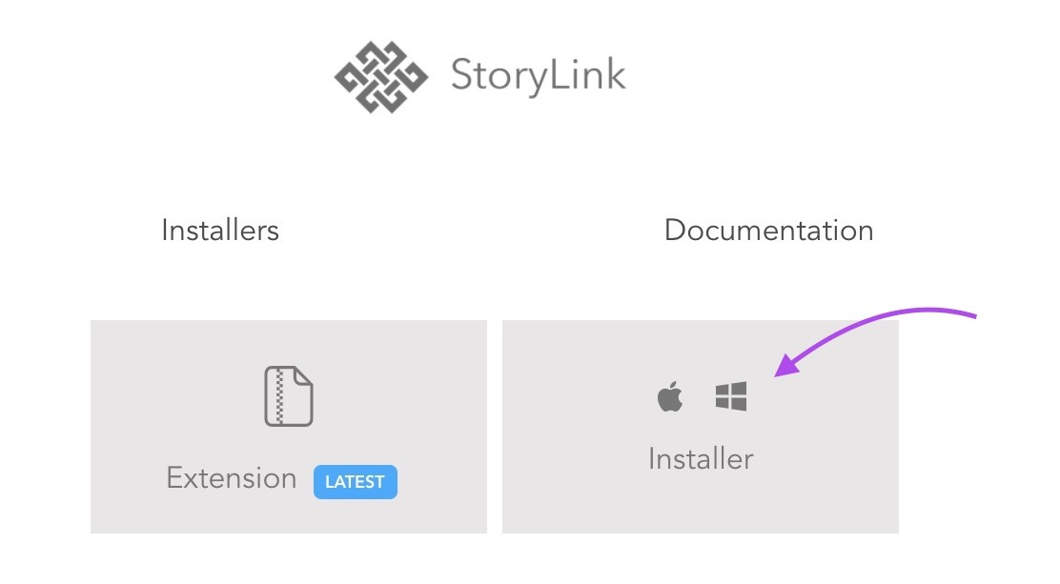

Step 2 - Download the <Application Name XYZ> extension. Get the latest release or choose an earlier version of the package from the list.

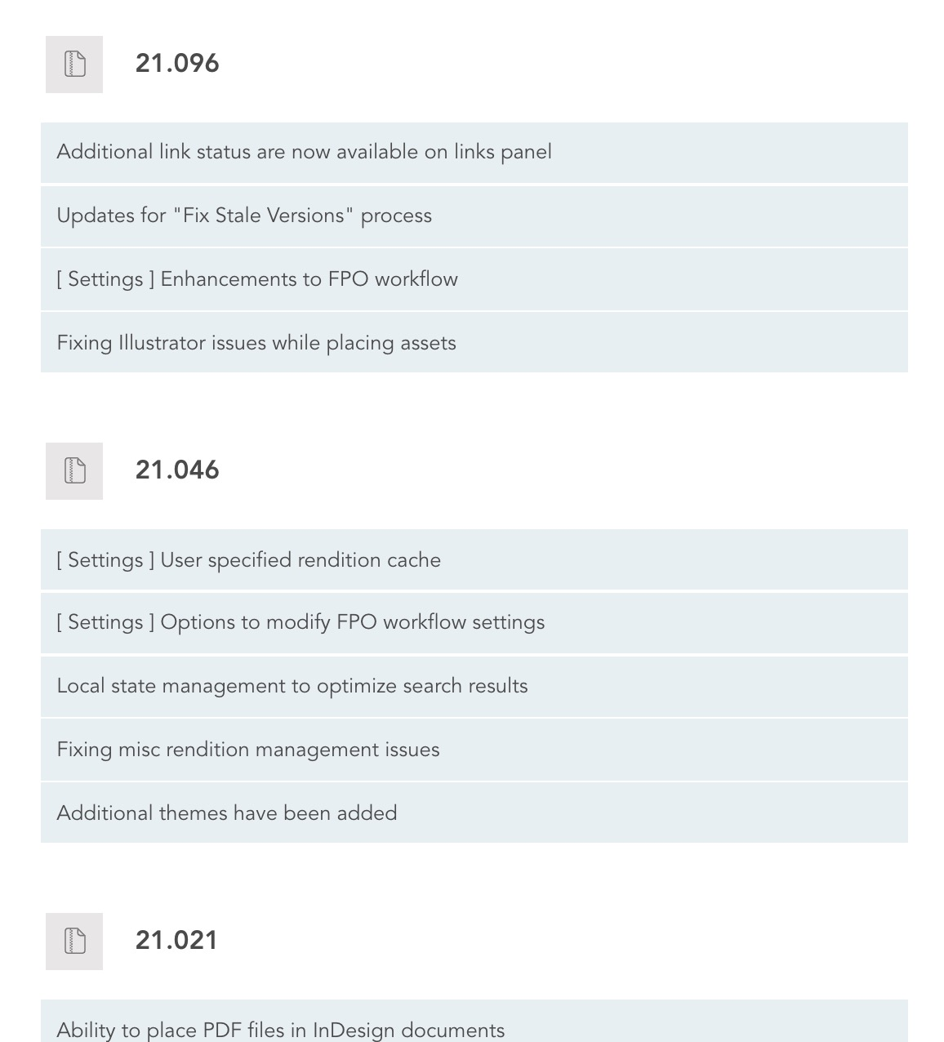

Note: By default, the packages are downloaded to the *Downloads* directory on your computer. In case your browser is configured to download to a different location, you would have to move the ZXP package to the *Downloads* directory.

### Extension Installation

Mac OS

Confirm that the Extension package (ZXP file) is downloaded and is in the Downloads directory.

Run the mac-install script to deploy the extension.

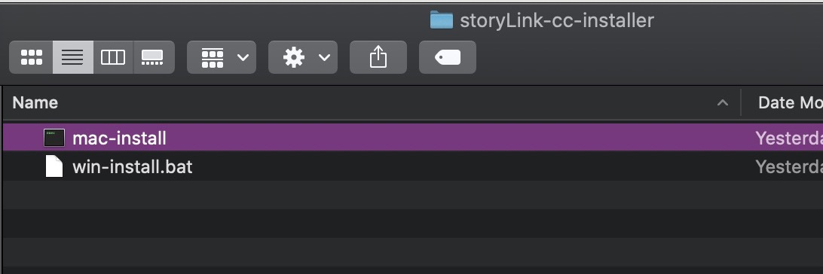

Note: When executing the script, the first time, you may see a warning from the OS. you can enable the script so that future executions would not require this exception.

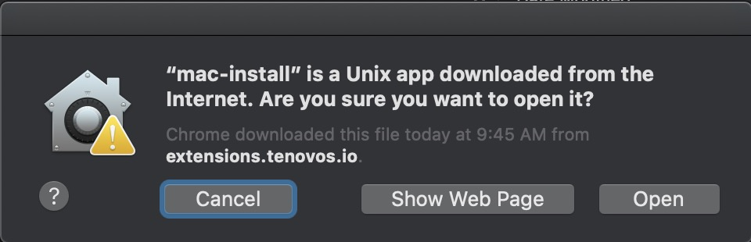

While the installer is running, it will prompt for the admin password. Once the script is successfully executed, the extension will be deployed indicated with the following message.

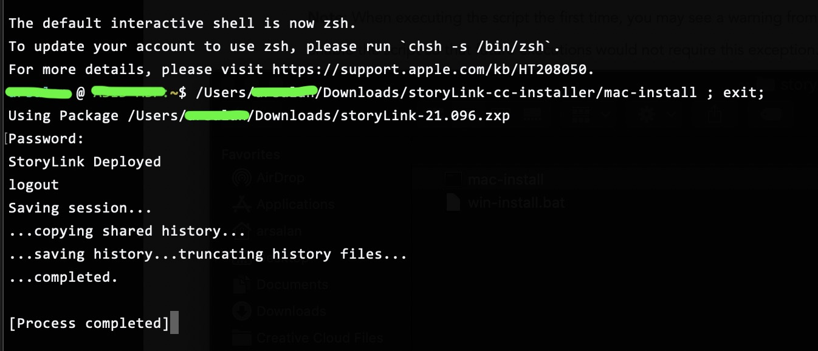

Windows

Confirm that the Extension package (ZXP file) is downloaded and is in the Downloads directory.

Run the win-install script to deploy the extension.

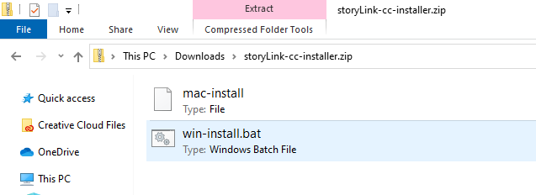

Note: When executing the script, the first time, you may see a warning from the OS. you can enable the script so that future executions would not require this exception.

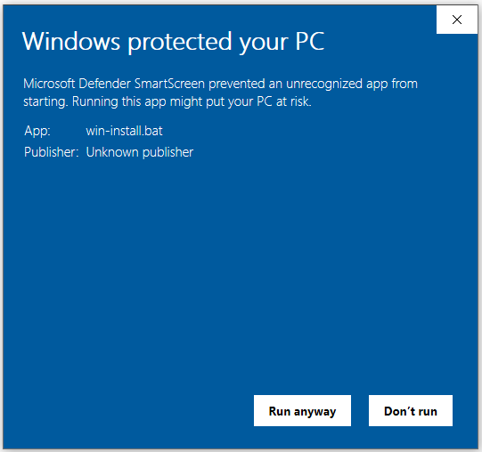

Once the script is successfully executed, the extension will be deployed indicated with the following message.

# Configuration Guide

This section helps you how to configure the <Application Name XYZ> extension to work with any of your DAM Platform. You must provide the login credentials along with the connection details of the DAM server. Once the setup is configured, it will allow you to access the platform and your assets directly on your Adobe Creative Cloud Application.

## Profile Creation

1. Launch your required Adobe Application.

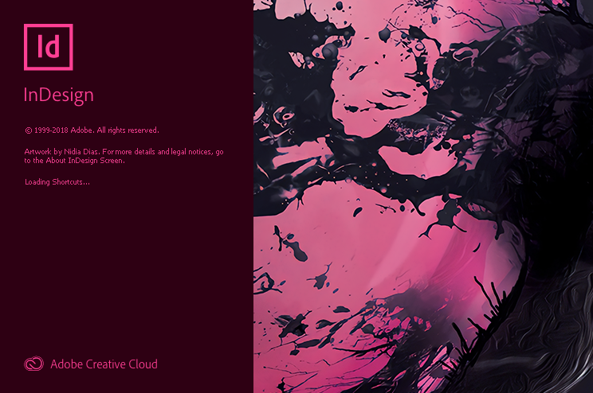

1. On Adobe InDesign go to Windows>Extensions><Application Name XYZ>.

(Removed screenshot for Privacy Purposes)

1. <Application Name XYZ> Application window will appear.
2. You must create a profile. Click on New Profile button.
3. Profile screen will appear to enter the configurations details of the DAM. By default, the login option is selected.

There are three ways to setup the configurations:

* 1. Login - A login is a set of credentials used to authenticate a user.
  2. MFA - Multi Factor Authentication (MFA) requires the user to provide two or more method of authentication to verify the user's identity to access the Tenovos Platform. It is an additional level of security enforced on the platform to avoid unnecessary brute force attacks. It is a process where a user is prompted during the sign-in process to enter the code which they can get from any of the authentication app installed in users mobile.
  3. SSO - Single sign-on (SSO) is an authentication method that enables users to authenticate securely within multiple applications having single credentials

1. You may select any of the three option to proceed with the configurations:
2. If you have selected Login option, you must enter the Profile Name, Username and Password.

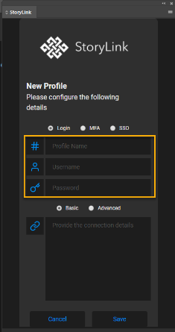

* + If you have selected MFA option, you must enter the Profile Name.
  + If you have selected SSO, you must enter the Profile Name and Cognito Provider Name.

1. For connection details you have following two options:

* Basic- If you have a connection string, you can enter the connection string directly into the box.
* Advanced- For Advanced setting you must enter the following parameters:
  + API Base URL
  + API Key
  + Cognito URL
  + Content URL
  + Client ID
  + User Pool ID

Note: ‎

If you enter the connection string in a box, value for these parameters will automatically populate.

If you enter the values, connection string will automatically generate.

1. 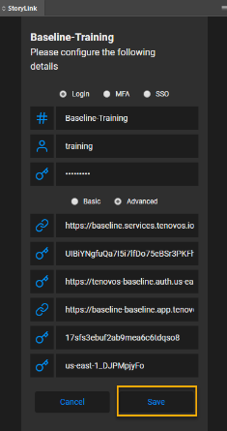Click Save to create the profile with the entered parameters.
2. Notification message will appear on top of the <Application Name XYZ> screen indicating that the "Profile has been Saved Successfully".

# Using <Application Name XYZ>

To access the <Application Name XYZ> extension you have to launch any of the following Adobe Applications:

* Adobe InDesign
* Adobe Illustrator
* Adobe Photoshop

## Launch Adobe Creative Cloud Application

You can see the <Application Name XYZ> extension in any of the following Creative Cloud Adobe applications.

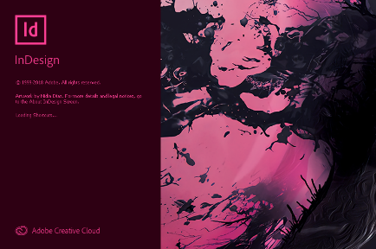   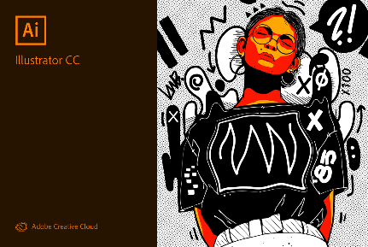   

Launch the Adobe CC application.

Go to Windows > Extensions > <Application Name XYZ>.

<Application Name XYZ> Application window will appear.

### Login

If you have already created a profile, select the profile and click the Connect.  Otherwise, click on New Profile button to create a new profile.

You will be connected, and your assets will start to display in the gallery view.

### Multi Factor Authentication (MFA)

If you already have a profile created with MFA option, select the profile and click the Connect button.  Otherwise, click on New Profile button to create a new profile.

You will be redirected to the Popup window to get the MFA authorization code screen.

Click Continue with Azure account ID.

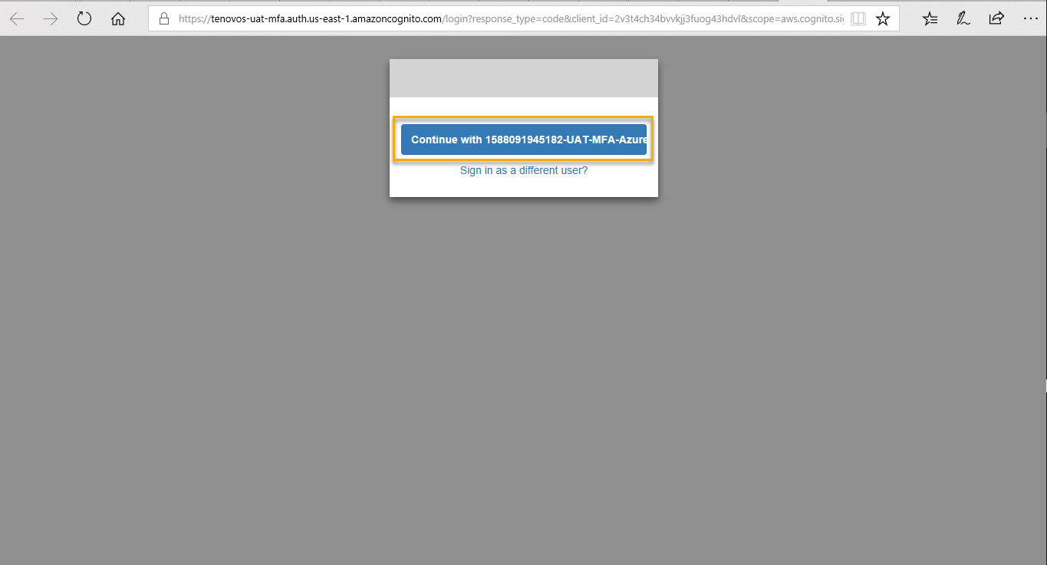

The screen will appear with authorization code with the message that "You have been granted access". Click the copy button to copy the Authorization Code to validate.

Enter the copied Authorization code in the <Application Name XYZ> application window to validate and click Validate Button.

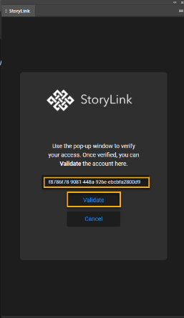

Click Continue to use <Application Name XYZ>.

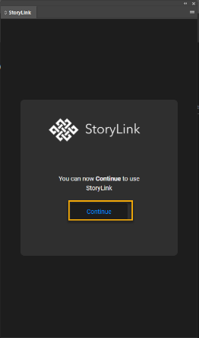

You will be launched with the required Tenovos Platform in Adobe InDesign Application's <Application Name XYZ> extension.

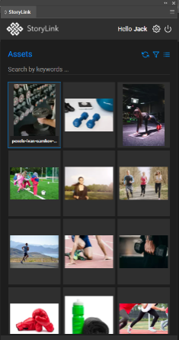

### Single Sign-on (SSO)

If you already have a profile created with SSO option, select the profile and click the Connect button.  Otherwise, click on New Profile button to create a new profile.

You will be redirected to the Popup window to get the authorization code screen.

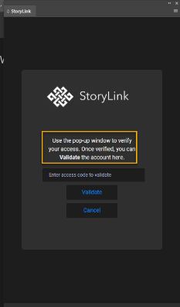

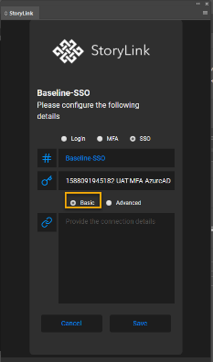The screen will appear with authorization code with the message that "You have been granted access". Click the copy button to copy the Authorization Code for validation.

Enter the copied Authorization code in the <Application Name XYZ> application window to validate and click the Validate Button.

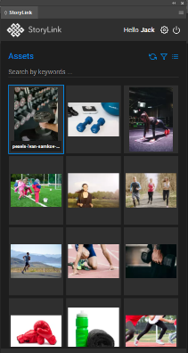

Click Continue to use <Application Name XYZ>.

You will be launched with the required DAM Platform in Adobe InDesign Application's <Application Name XYZ> extension.